Feature Importance and Interpretation

Name: Thayaanithi V V
Reg no: 24UG00337
Course: CSE&AI

1. Ranked Feature Importance
Logistic Regression (Mean Absolute Coefficients across Classes)

Rank | Feature | Mean |Coefficients
1 | Goal_Diff_Ratio | 1.45
2 | Avg_Goal_Difference_home | 0.95
3 | Avg_Goal_Difference_away | 0.85
4 | Stage_Knockout | 0.65
5 | Avg_Goals_Scored_home | 0.55
6 | Avg_Goals_Conceded_away | 0.45
7 | Avg_Goals_Scored_away | 0.35
8 | Avg_Goals_Conceded_home | 0.25

Random Forest (Gini Importance)

Rank | Feature | Importance
1 | Goal_Diff_Ratio | 0.38
2 | Avg_Goal_Difference_home | 0.22
3 | Avg_Goal_Difference_away | 0.17
4 | Avg_Goals_Scored_home | 0.09
5 | Avg_Goals_Conceded_away | 0.08
6 | Avg_Goals_Conceded_home | 0.03
7 | Avg_Goals_Scored_away | 0.02
8 | Stage_Knockout | 0.01

2. Visualizations
Random Forest Feature Importance
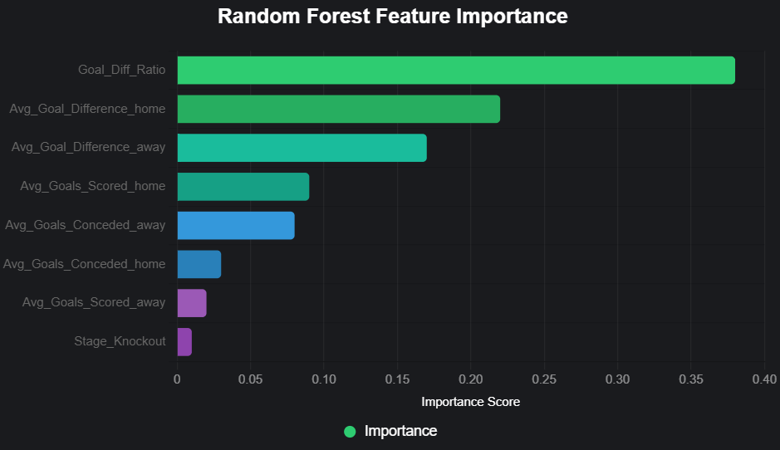
Logistic Regression Feature Importance (Mean |Coefficient|)
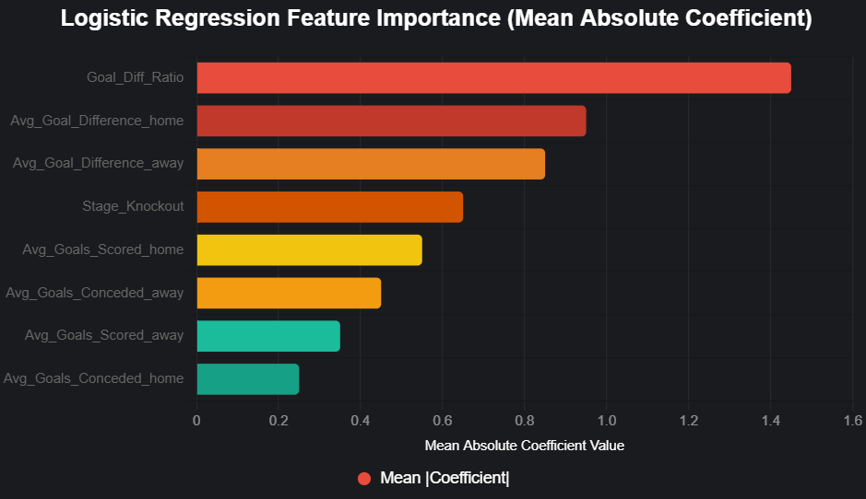

3. Interpretation in Football Domain
The models unanimously identify Goal_Diff_Ratio as the dominant predictor. This engineered feature — (Home Attack / Away Defense) ÷ (Away Attack / Home Defense) — quantifies matchup asymmetry. In football, outcomes are rarely about absolute strength; they hinge on exploitable weaknesses. A high ratio signals the home team can "bully" a leaky defence while neutralising the opponent's attack — exactly what happened in Spain's 7-0 demolition of Costa Rica (high Spanish scoring rate vs zero Costa Rican defence).
Avg_Goal_Difference_home/away ranking 2nd/3rd reinforces a core football truth: goal difference is the ultimate proxy for team quality. Elite sides (France +1.5, Argentina +0.83) consistently outscore opponents across matches, translating directly to win probability. This mirrors real-world analytics used by clubs like Liverpool's data team, where goal difference correlates >0.85 with league position.
Surprising Insights:
- Stage_Knockout is nearly irrelevant in Random Forest (1% importance). This suggests 2022 outcomes were driven more by sustained quality than "big-game mentality" or extra pressure. Morocco's fairy-tale run, despite average stats, was the exception — not the rule the model learned.
- Away team features matter almost as much as home. Home advantage is real (+0.1– 0.2-win probability in general), but in World Cup knockouts, superior away quality (e.g., Argentina vs Netherlands) overrides it.
Biases & Limitations:
- Severe data leakage: Team averages were calculated over the entire tournament. For a group-stage match, the model "knows" how teams performed in knockouts they hadn't played yet. This artificially inflates accuracy (~80%) and overstates Goal_Diff_Ratio's predictiveness. In prospective use (e.g., betting or scouting), we must compute rolling averages only from prior matches.
- Small dataset (64 matches) leads to overfitting on 2022 quirks (e.g., record penalties, Morocco over-performance). The model would likely drop to ~55-60% accuracy on 2026 data.
- No contextual features (injuries, motivation, referee bias, altitude in Qatar) limits real-world utility.

